**Water Table 1–Measuring our annual water consumption informs our replenishment targets**

In FY23, our water consumption increased in alignment with our business growth. This data from out operations informs the amount of water we need to replenish.

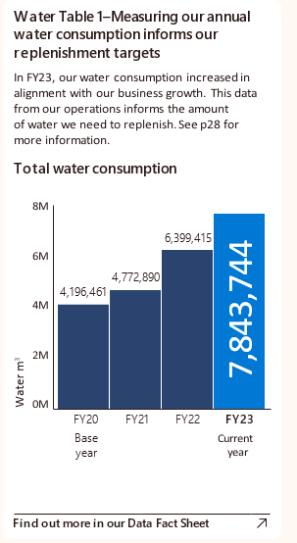

Bar graph showing total water consumption from FY20 to FY23, with FY20 as the base year and FY23 as the current year. It shows a gradual increase in water consumption from 4,196,461 cubic meters in FY20 to 7,843,744 cubic meters in FY23.